17.2.4 Thrust Calculations

Various formulae exist to calculate gross engine thrust (Fg). However, modern engines are too complex for standard textbook formulas to accurately predict thrust; this is normally left to complex computer algorithms. The current standard for new models is the Numerical Propulsion System Simulation (NPSS). Despite this, a control volume approach relying on conservation of momentum will provide gross engine thrust if the required parameters are known.

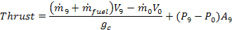

Where subscript 9 represents the nozzle exit and subscript 0 represents the freestream conditions. , V, and, P represent mass flow rate, velocity, and static pressure respectively.

Variations and simplifications of this formula exist:

Turbojet and Low Bypass Turbofan (Mixed Streams) | 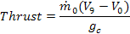
High Bypass Turbofan  (Separate Streams) | 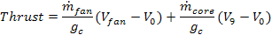

Atmospheric temperature, Mach, and altitude also significantly affect engine thrust and efficiency.

